|  |  |  |  |  |  |
| --- | --- | --- | --- | --- | --- |
| Date | 8-Dec-22 | | | Tester Name | Richard Belanger |
| Environment | Penfax - Test | | | Login used | TEST2 |
| Operating System | Windows | Version: | Update: | | |
| Software Used | Edge | Version: | Update: | | |
| Not Applicable | Version: | Update: | | |
| Release version | 22.4.1 | | | | |
| Title | M51.30 Two Years Break in Service Report - Ad-hoc Batch | | | | |
| Test Type | Regression | | | | |
| Test Scenario | Run the Two Year Break Report | | | | |
|  |  | | | | |
| Expected Results | Report will run and be verified to PENFAX | | | | |
| Pass/Fail | Pass | | | JIRA# | N/A |

Describe your steps with screenshots:

Set up the Report for City of Prince Albert>Full Time members>Click Save

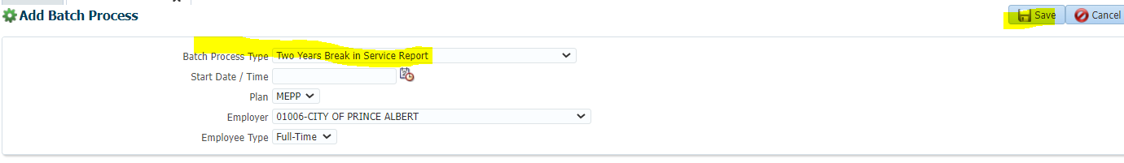

Succeeded

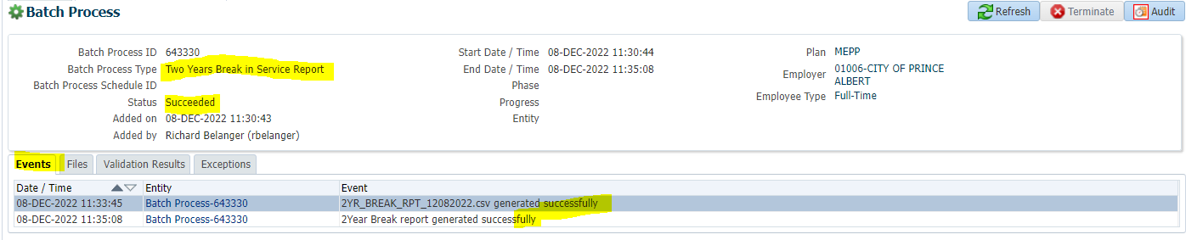

Files Tab

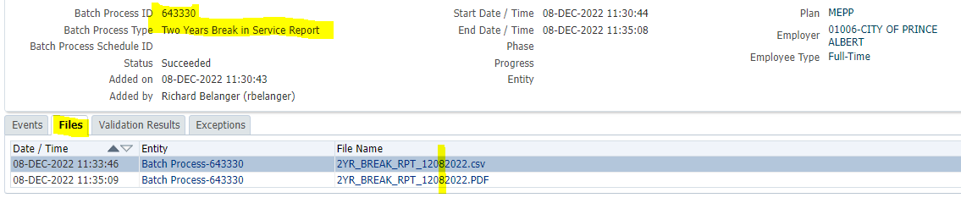

PDF Report created with no records as no Two Year break members

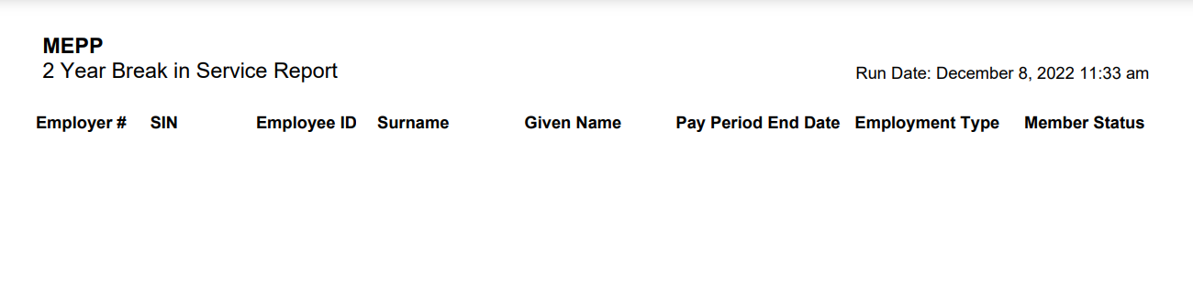

CSV Report created with no records as no Two Year break members

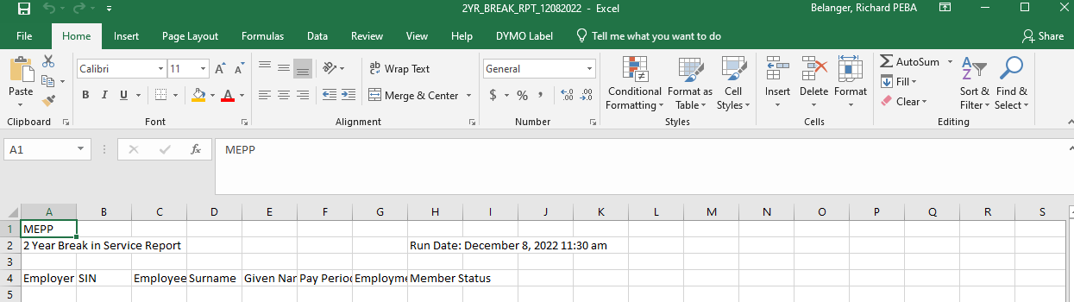

Run for All MEPP

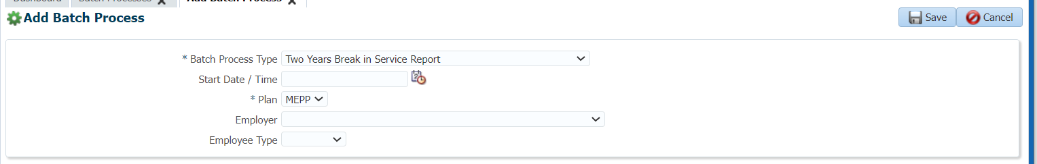

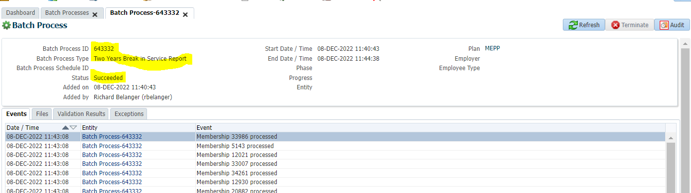

Files

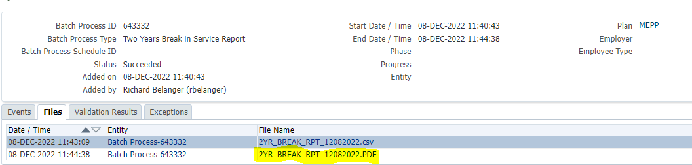

Open PDF of Report

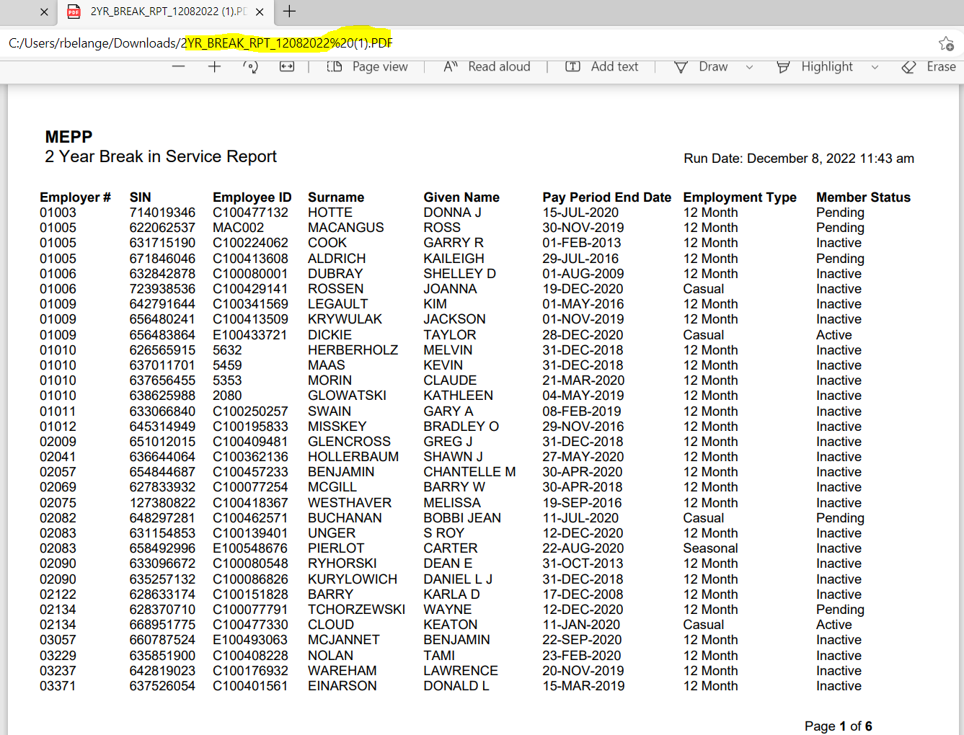

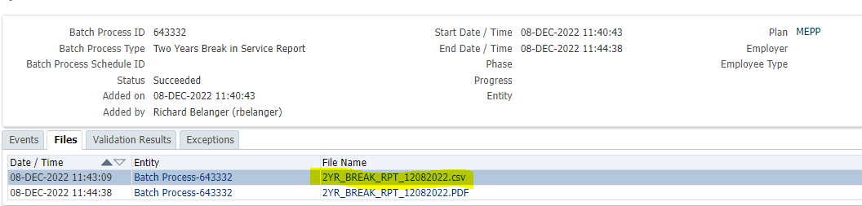

Open CSV of Report

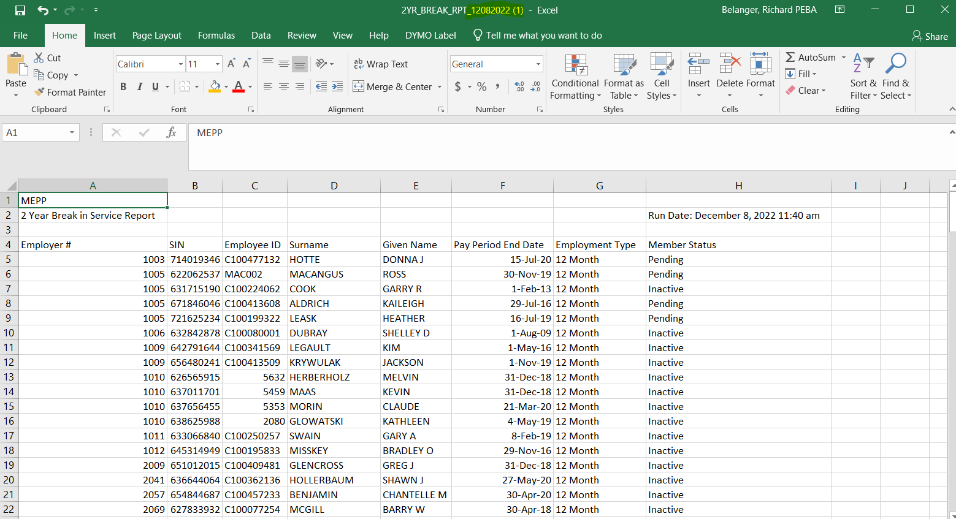

Verify that members on report have a Two Year break in service

SIN = 714019346

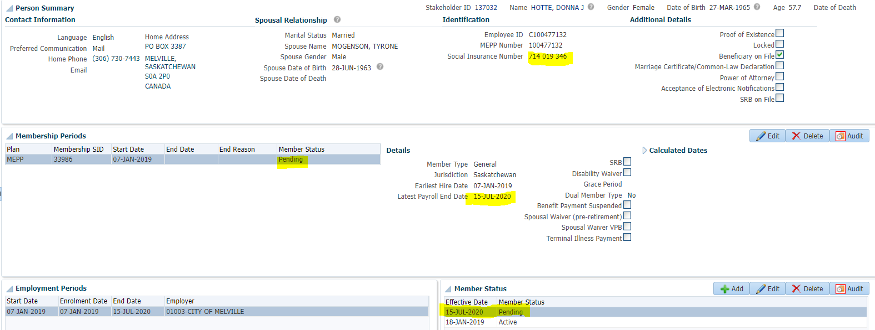

SIN = 632842878

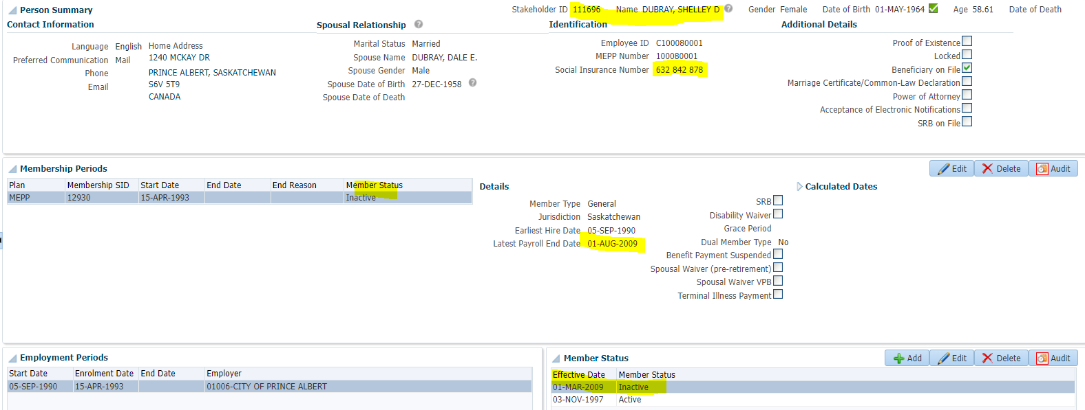

SIN = 717490163

